**DAILY ONLINE ACTIVITIES SUMMARY**

|  |  |  |  |  |  |  |  |
| --- | --- | --- | --- | --- | --- | --- | --- |
| **Date:** | **23 may 2020** | | | | **Name:** | **Sinchana K N** | |
| **Sem & Sec** | **4th sem, B sec** | | | | **USN:** | **4al18cs083** | |
| **Online Test Summary** | | | | | | | |
| **Subject** | | **DATA COMMUNICATION** | | | | | |
| **Max. Marks** | | **30** | | **Score** | | **25** | |
| **Certification Course Summary** | | | | | | | |
| **Course** | **Java Programing** | | | | | | |
| **Certificate Provider** | | | **great learning** | **Duration** | | | **5 hours** |
| **Coding Challenges** | | | | | | | |
| **Problem Statement:4 program** | | | | | | | |
| **Status: Executed** | | | | | | | |
| **Uploaded the report in Github** | | | | **Yes** | | | |
| **If yes Repository name** | | | | <https://github.com/acchu1234sinchana/Lockdown_coding1> | | | |
| **Uploaded the report in slack** | | | | **Yes** | | | |

**Online Test Summary:**

Today **DATA COMMUNICATION** was conducted of first and second module. Total marks for the test was 30.The online test conducted includes MCQ kind questions.

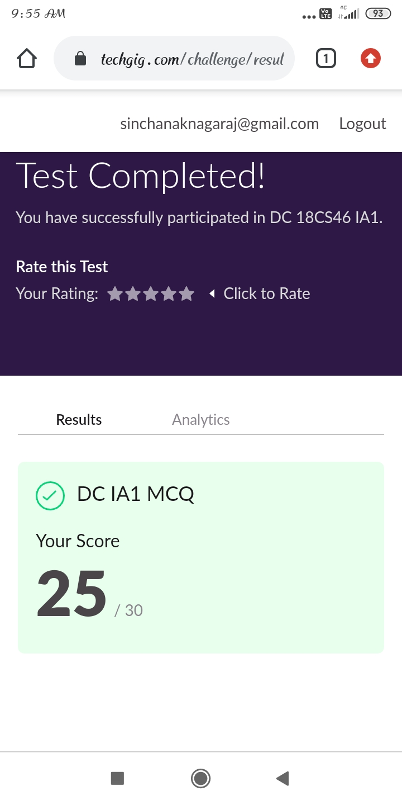

**Certification Course Summary:**

Today I started new certificate course through Great learning. I choose the concept of Java programming. I learnt about Agenda, what is java, Installing of java and java IDK, First java program, Variables and Data types, Operators in java, Flow Control Statements in java.

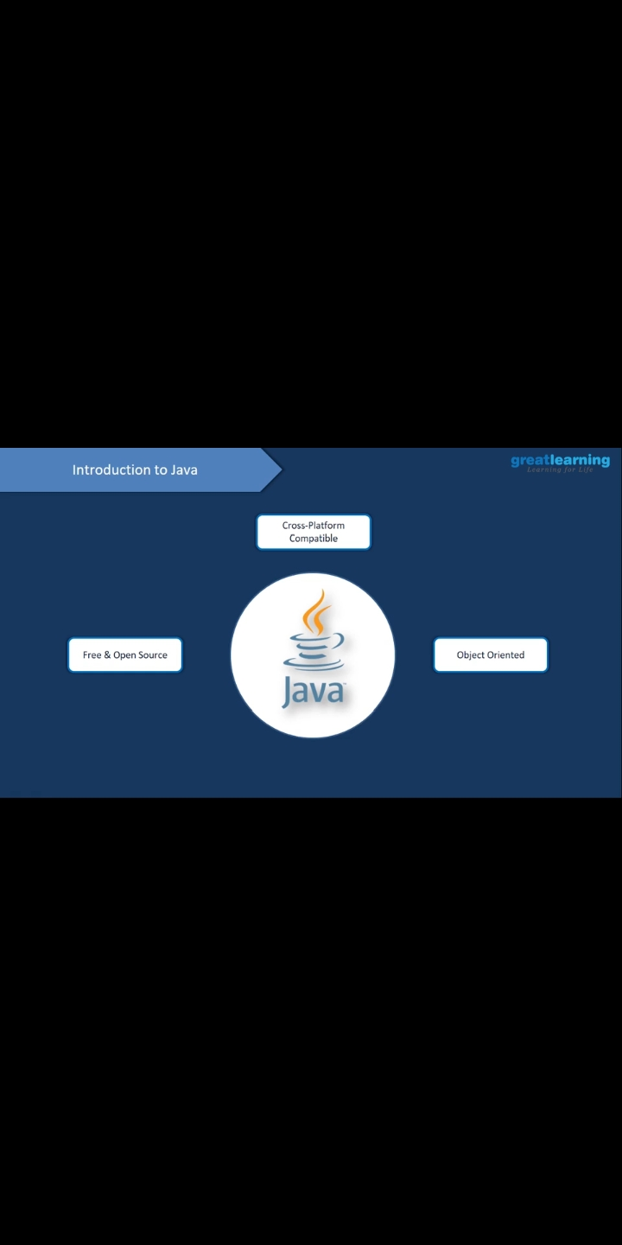

**Coding Challenges:**

